***This is a bonus Web chapter

CHAPTER 44

JavaServer Faces

Objectives

- To explain what JSF is (§44.1).
- To create a JSF page using NetBeans (§44.2).
- To create a JSF managed bean (§44.2).
- To use JSF expressions in a facelet (§44.2).
- To use JSF GUI components (§44.3).
- To obtain and process input from a form (§44.4).
- To track sessions in application, session, view, and request scope (§44.5).
- To validate input using the JSF validators (§44.6).
- To bind database with facelets (§44.7).

44.1 Introduction
<margin note: servlets>
<margin note: JSP>
<margin note: JSF>
The use of servlets, introduced in Chapter 42, is the foundation of the Java Web technology. It is a primitive way to write server-side applications. JSP, introduced in Chapter 43, provides a scripting capability and allows you to embed Java code in XHTML. It is easier to develop Web programs using JSP than servlets. However, JSP has some problems. First, it can be very messy, because it mixes Java code with HTML. Second, using JSP to develop user interface is tedious. JavaServer Faces (JSF) comes to rescue. JSF enables you to completely separate Java code from HTML. You can quickly build web applications by assembling reusable UI components in a page, connecting these components to Java programs, and wiring client-generated events to server-side event handlers. The application developed using JSF is easy to debug and maintain.

<margin note: JSF 2>
<margin note: XHTML>
<margin note: CSS>
NOTE: This chapter introduces JSF 2, the latest standard for JavaServer Faces. You need to know XHTML (eXtensible HyperText Markup Language) and CSS (Cascading Style Sheet) to start this chapter. For information on XHTML and CSS, see Supplements Part V.A and Part V.B on the companion Website.

44.2 Getting Started with JSF
A simple example will illustrate the basics of developing JSF projects using NetBeans. The example is to display the date and time on the server, as shown in Figure 44.1.

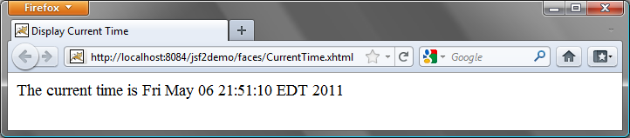

Figure 44.1
The application displays the date and time on the server.

44.2.1 Creating a JSF Project
Here are the steps to create the application.

<margin note: create a project>
Choose File › New Project to display the New Project dialog box. In this box, choose Java Web in the Categories pane and Web Application in the Projects pane. Click Next to display the New Web Application dialog box.
In the New Web Application dialog box, enter and select the following fields, as shown in Figure 44.2a:
Project Name: jsf2demo
Project Location: c:\book
Check Set as Main Project

Click Next to display the dialog box for choosing servers and settings. Select the following fields as shown in Figure 44.2b. (Note: You can use any server such as GlassFish 3.x that supports Java EE 6.)
Server: Apache Tomcat 7.0.11
Java EE Version: Java EE 6 Web

Click Next to display the dialog box for choosing frameworks, as shown in Figure 44.3. Check JavaServer Faces and JSF 2.0 as Registered Libraries. Click Finish to create the project, as shown in Figure 44.4.

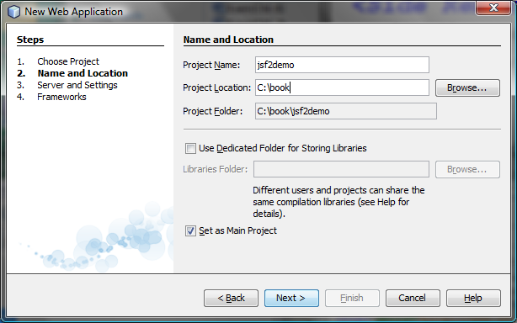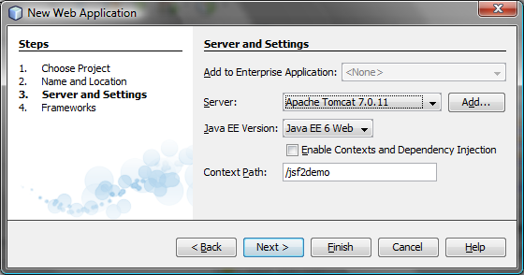
(a) (b)

Figure 44.2
The New Web Application dialog box enables you to create a new Web project.
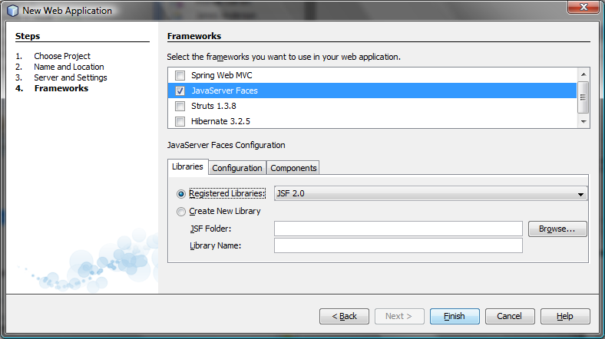

Figure 44.3
Check JavaServer Faces and JSF 2.0 to create the Web project.
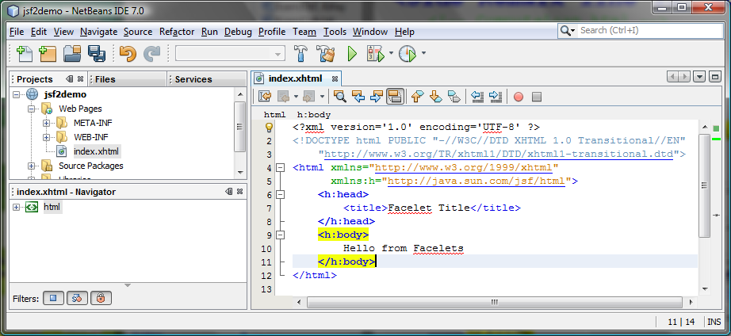
Figure 44.4
A default JSF page is created in a new Web project.

44.2.2 A Basic JSF Page
<margin note: facelet>
A new project was just created with a default page named index.xhtml, as shown in Figure 44.4. This page is known as a facelet, which mixes JSF tags with XHTML tags. Listing 44.1 lists the contents of index.xhtml.

Listing 44.1 index.xhtml
***PD: Please add line numbers in the following code***
***Layout: Please layout exactly. Don’t skip the space. This is true for all source code in the book. Thanks, AU.
<margin note line 1: xml version>
<margin note line 2: comment>
<margin note line 3: DOCTYPE>
<margin note line 5: default namespace>
<margin note line 6: JSF namespace>
<margin note line 7: h:head>
<margin note line 10: h:body>

<?xml version='1.0' encoding='UTF-8' ?>
<!-- index.xhtml -->
<!DOCTYPE html PUBLIC "-//W3C//DTD XHTML 1.0 Transitional//EN"
"http://www.w3.org/TR/xhtml1/DTD/xhtml1-transitional.dtd">
<html xmlns="http://www.w3.org/1999/xhtml"
xmlns:h="http://java.sun.com/jsf/html">
<h:head>
<title>Facelet Title</title>
</h:head>
<h:body>
Hello from Facelets
</h:body>
</html>

<margin note: XML declaration>
Line 1 is an XML declaration to state that the document conforms to the XML version 1.0 and uses the UTF-8 encoding. The declaration is optional, but it is a good practice to use it. Otherwise, a document without the declaration may be assumed of a different version, which may lead to errors. If an XML declaration is present, it must be the first item to appear in the document. This is because an XML processor looks for the first line to obtain information about the document so that it can be processed correctly.

<margin note: XML comment>
Line 2 is a comment for documenting the contents in the file. XML comment always begins with <!-- and end with -->.

<margin note: DOCTYPE>
Lines 3-4 specifies the version of XHTML used in the document. This can be used by the Web browser to validate the syntax of the document.

<margin note: element>
<margin note: tag>
An XML document consists of elements described by tags. An element is enclosed between a start tag and an end tag. XML elements are organized in a tree-like hierarchy. Elements may contain subelements, but there is only one root element in an XML document. All the elements must be enclosed inside the root tag. The root element in XHTML is defined using the html tag (line 5).

Each tag in XML must be used in a pair of the start tag and the end tag. A starting begins with < followed by the tag name, and ends with >. An end tag is the same as its starting except it begins with </. The start tag and end tag for html are <html> and </html>.

<margin note: html tag>
The html element is the root element that contains all other elements in an XHTML page. The starting <html> tag (lines 5-6) may contain one or more xmlns (XML namespace) attributes to specify the namespace for the elements used in the document. Namespaces are like Java packages. Java packages are used to organize classes and to avoid naming conflict. XHMTL namespaces are used to organize tags and resolve naming conflict. If an element with the same name is defined in two namespaces, the fully qualified tag names can be used to differentiate them.

<margin note: xmlns>
Each xmlns attribute has a name and a value separated by an equal sign (=). The following declaration (line 5)

xmlns="http://www.w3.org/1999/xhtml"

specifies that any unqualified tag names are defined in the default standard xhtml namespace.

The following declaration (line 6)

xmlns:h="http://java.sun.com/jsf/html"

allows the tags defined in the JSF tag library to be used in the document. These tags must have a prefix h.

<margin note: h:head>
An html element contains a head and body. The h:head element (lines 7-9) defines an HTML title element. The title is usually displayed in the browser window’s title bar.

<margin note: h:body>
A h:body element defines the page’s content. In this simple example, it contains a string to be displayed in the Web browser.

NOTE: The XML tag names are case-sensitive, whereas HTML tags are not. So, <html> is different from <HTML> in XML. Every start tag in XML must have a matching end tag; whereas some tags in HTML does not need end tags.
You can now display the JSP page in index.xhtml by right-clicking on index.xhtml in the projects pane. The page is displayed in a browser, as shown in Figure 44.5.

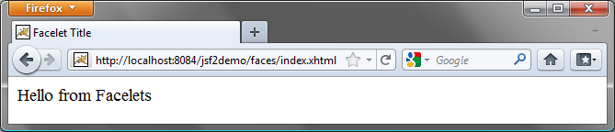
Figure 44.5
The index.xhtml is displayed in the browser.

44.2.3 Managed JavaBeans for JSF
JSF applications are developed using the Model-View-Controller (MVC) architecture, which separates the application’s data (contained in the model) from the graphical presentation (the view). The controller is the JSF framework that is responsible for coordinating interactions between view and the model.

In JSF, the facelets are the view for presenting data. Data are obtained from Java objects. Objects are defined using Java classes. In JSF, the objects that are accessed from a facelet are JavaBeans objects. If you are not familiar with JavaBeans, please read Chapter 36, “JavaBeans.”

Our example in this section is to develop a JSF facelet to display current time. We will create JavaBean with a getTime() method that returns the current time as a string. The facelet will invoke this method to obtain current time.

Here are the steps to create a JavaBean named TimeBean.

Step 1. Right-click the project node jsf2demo to display a context menu as shown in Figure 44.6. Choose New, JSF Managed Bean to display the New JSF Managed Bean dialog box, as shown in Figure 44.7. (Note: if you don’t see JSF Managed Bean in the menu, choose Other to locate JSF Managed Bean.)

Step 2. Enter and select the following fields, as shown in Figure 44.8:
Class Name: TimeBean
Package: jsf2demo
Name: timeBean
Scope: request
Click Finish to create TimeBean.java, as shown in Figure 44.9.

Step 3. Add the getTime() method to return the current time, as shown in Listing 44.2.

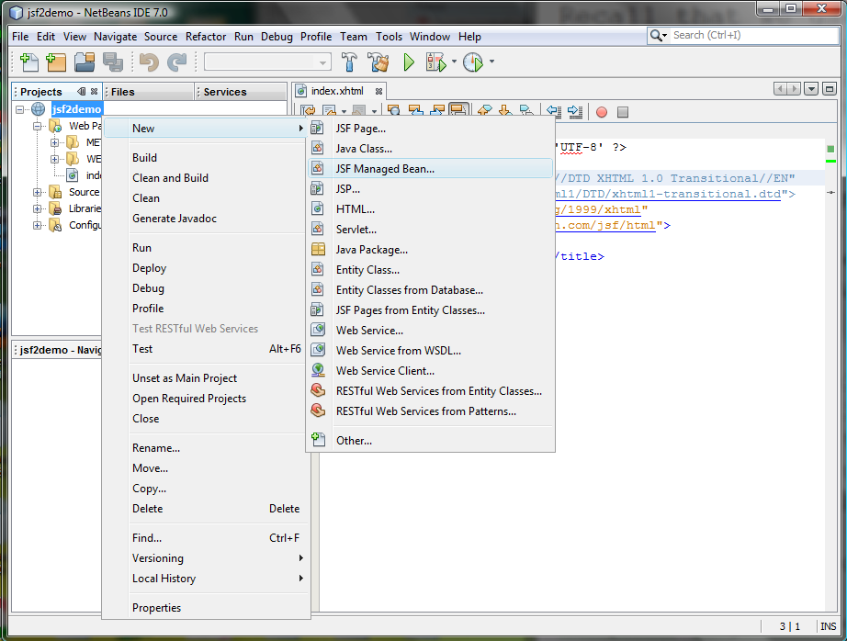
Figure 44.6
Choose JSF Managed Bean to create a JavaBean for JSF.

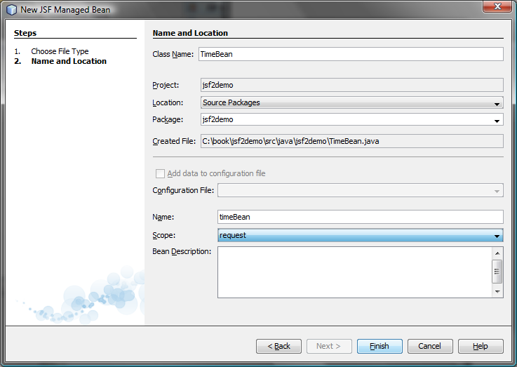
Figure 44.7
Specify the name, location, scope for the bean.

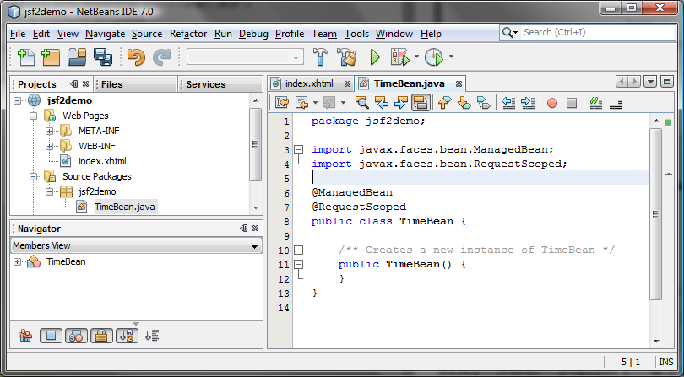
Figure 44.8
A JavaBean for JSF was created.

Listing 44.2 TimeBean.java
<margin note line 6: @ManagedBean>
<margin note line 7: @RequestScoped>
<margin note line 9: time property>

package jsf2demo;

import javax.faces.bean.ManagedBean;
import javax.faces.bean.RequestScoped;

@ManagedBean
@RequestScoped
public class TimeBean {
public String getTime() {
return new java.util.Date().toString();
}
}

<margin note: @ManagedBean>
TimeBean is a JavaBeans with the @ManagedBean annotation, which indicates that the JSF framework will create and manage the TimeBean objects used in the application. You have learned to use the @Override annotation in Chapter 15. The @Override annotation tells the compiler that the annotated method is required to override a method in a superclass. The @ManagedBean annotation tells the compiler to generate the code to enable the bean to be used by JSF facelets.

<margin note: @RequestScope>
The @RequestScope annotation specifies the scope of the JavaBeans object is within a request. The JSP scopes were introduced in the preceding chapter. You can also use @SessionScope or @ApplicationScope to specify the scope for a session or for the entire application.

44.2.4 JSF Expressions
Recall that we used JSP scripting to enter Java code in an HTML file to return the current time in the preceding chapter. But JSP scripting will not work with JSF. How can you display the current time from a JSF page? You can display current time by invoking the getTime() method in a TimeBean object using a JSF expression.

To keep index.xhtml intact, we create a new JSF page named CurrentTime.xhtml as follows:

Step 1. Right-click the jsf2demo node in the project pane to display a context menu and choose New, JSF Page to display the New JSF File dialog box, as shown in Figure 44.9.

Step 2. Enter CurrentTime in the File Name field, choose Facelets and click Finish to generate CurrentTime.xhmtl, as shown in Figure 44.10.

Step 3. Add a JSF expression to obtain the current time, as shown in Listing 44.3.

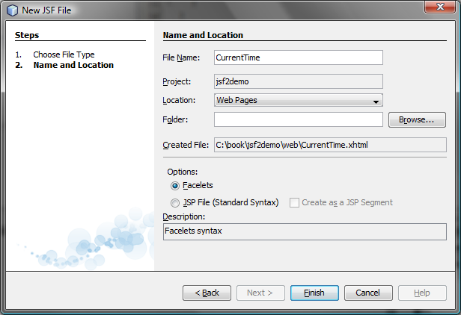
Figure 44.9
The New JSF File dialog is used to create a JSF page.

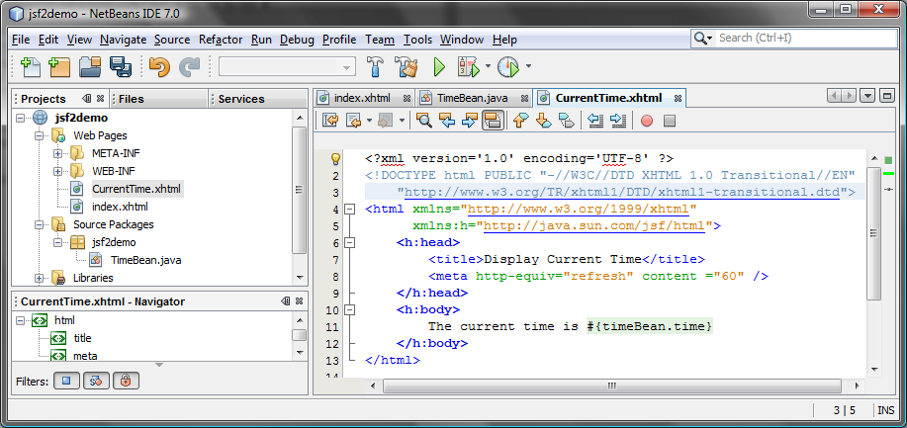
Figure 44.10
A New JSF page CurrentTime was created.

Listing 44.3 CurrentTime.xhtml
<margin note line 8: refresh page>
<margin note line 11: JSF expression>

<?xml version='1.0' encoding='UTF-8' ?>
<!DOCTYPE html PUBLIC "-//W3C//DTD XHTML 1.0 Transitional//EN"
"http://www.w3.org/TR/xhtml1/DTD/xhtml1-transitional.dtd">
<html xmlns="http://www.w3.org/1999/xhtml"
xmlns:h="http://java.sun.com/jsf/html">
<h:head>
<title>Display Current Time</title>
<meta http-equiv="refresh" content ="60" />
</h:head>
<h:body>
The current time is #{timeBean.time}
</h:body>
</html>

Line 8 defines a meta tag inside the h:head tag to tell the browser to refresh every 60 seconds. This line can also be written as

<meta http-equiv="refresh" content ="60"></ meta>

<margin note: empty element>
An element is called an empty element if there are no contents between the start tag and end tag. In an empty element, data is typically specified as attributes in the start tag. You can close an empty element by placing a slash immediately preceding the start tag’s right angle bracket, as shown in line 8, for brevity.

Line 8 uses a JSF expression #{timeBean.time} to obtain the current time. timeBean is an object of the TimeBean class. The object name can be changed in the @ManagedBean annotation (line 6 in Listing 44.2) using the following syntax:

@ManagedBean(name="anyObjectName")

By default the object name is the class name with the first letter in lowercase.

Note that time is a JavaBeans property, because the getTime() method is defined in TimeBeans. The JSF expression can either use the property name or invoke the method to obtain the current time. So the following two expressions are both fine.

#{timeBean.time}
#{timeBean.getTime()}

The syntax of a JSF expression is

#{expression}

JSF expressions bind JavaBeans objects with facelets. You will see more use of JSF expressions in the upcoming examples in this chapter.

44.3 JSF GUI Components
JSF provides many elements for displaying GUI components. Table 44.1 lists some of the commonly used elements. The tags with the h prefix are in the JSF HTML Tag library. The tags with the f prefix are in the JSF Core Tag library.

Table 44.1
JSF GUI Form Elements
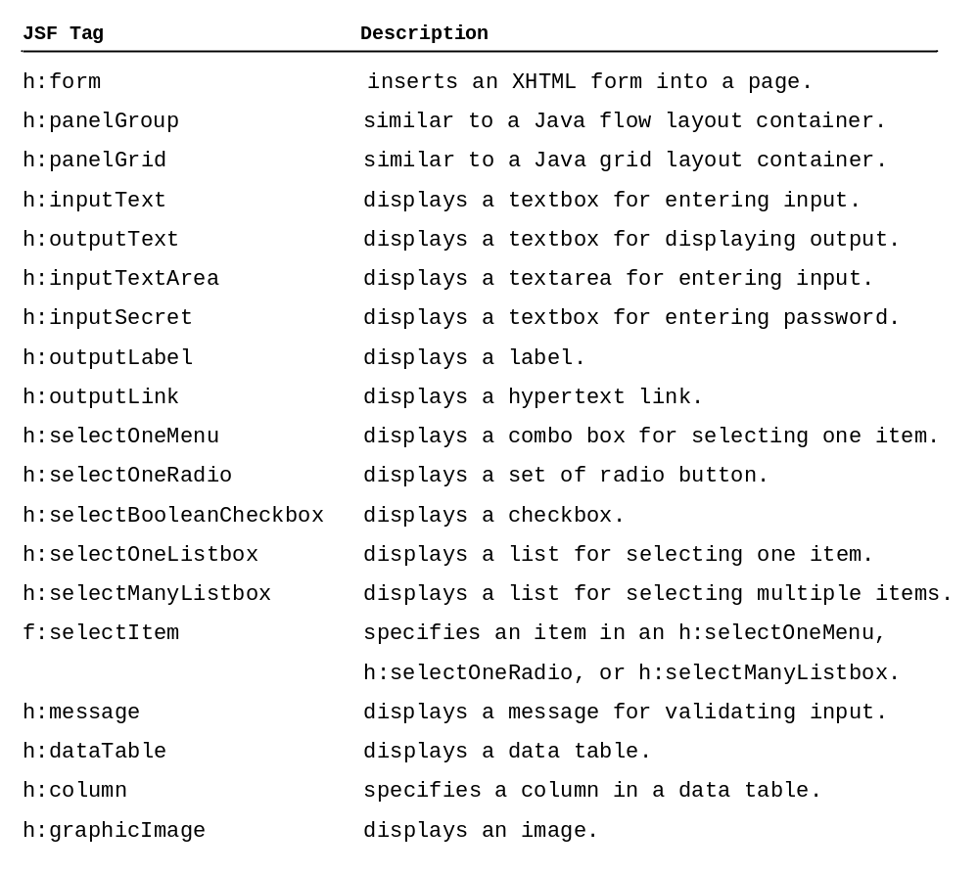

Listing 44.4 is an example that uses some of these elements to display a student registration form, as shown in Figure 44.11.

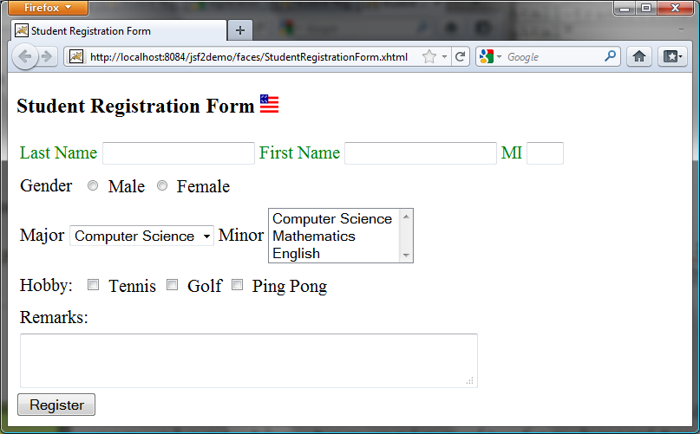
Figure 44.11
A student registration form is displayed using JSF elements.

Listing 44.4 StudentRegistrationForm.xhtml
<margin note line 6: jsf core namespace>
<margin note line 14: graphicImage>
<margin note line 18: h:panelGrid>
<margin note line 19: h:outputLabel>
<margin note line 20: h:inputText>
<margin note line 30: h:selectOneRadio>
<margin note line 31: f:selectItem>
<margin note line 41: h:selectOneMenu>
<margin note line 46: h:selectManyListBox>
<margin note line 56: h:selectManyCheckbox>
<margin note line 66: h:inputTextarea>
<margin note line 71: h:commandButton>

<?xml version='1.0' encoding='UTF-8' ?>
<!DOCTYPE html PUBLIC "-//W3C//DTD XHTML 1.0 Transitional//EN"
"http://www.w3.org/TR/xhtml1/DTD/xhtml1-transitional.dtd">
<html xmlns="http://www.w3.org/1999/xhtml"
xmlns:h="http://java.sun.com/jsf/html"
xmlns:f="http://java.sun.com/jsf/core">
<h:head>
<title>Student Registration Form</title>
</h:head>
<h:body>
<h:form>
<!-- Use h:graphicImage -->
<h3>Student Registration Form
<h:graphicImage name="usIcon.gif" library="image"/>
</h3>

<!-- Use h:panelGrid -->
<h:panelGrid columns="6" style="color:green">
<h:outputLabel value="Last Name"/>
<h:inputText id="lastNameInputText" />
<h:outputLabel value="First Name" />
<h:inputText id="firstNameInputText" />
<h:outputLabel value="MI" />
<h:inputText id="miInputText" size="1" />
</h:panelGrid>

<!-- Use radio buttons -->
<h:panelGrid columns="2">
<h:outputLabel>Gender </h:outputLabel>
<h:selectOneRadio id="genderSelectOneRadio">
<f:selectItem itemValue="Male"
itemLabel="Male"/>
<f:selectItem itemValue="Female"
itemLabel="Female"/>
</h:selectOneRadio>
</h:panelGrid>

<!-- Use combo box and list -->
<h:panelGrid columns="4">
<h:outputLabel value="Major "/>
<h:selectOneMenu id="majorSelectOneMenu">
<f:selectItem itemValue="Computer Science"/>
<f:selectItem itemValue="Mathematics"/>
</h:selectOneMenu>
<h:outputLabel value="Minor "/>
<h:selectManyListbox id="minorSelectManyListbox">
<f:selectItem itemValue="Computer Science"/>
<f:selectItem itemValue="Mathematics"/>
<f:selectItem itemValue="English"/>
</h:selectManyListbox>
</h:panelGrid>

<!-- Use check boxes -->
<h:panelGrid columns="4">
<h:outputLabel value="Hobby: "/>
<h:selectManyCheckbox id="hobbySelectManyCheckbox">
<f:selectItem itemValue="Tennis"/>
<f:selectItem itemValue="Golf"/>
<f:selectItem itemValue="Ping Pong"/>
</h:selectManyCheckbox>
</h:panelGrid>

<!-- Use text area -->
<h:panelGrid columns="1">
<h:outputLabel>Remarks:</h:outputLabel>
<h:inputTextarea id="remarksInputTextarea"
style="width:400px; height:50px;" />
</h:panelGrid>

<!-- Use command button -->
<h:commandButton value="Register" />
</h:form>
</h:body>
</html>

<margin note: jsf core xmlns>
The tags with prefix f are in the JSF core tag library. Line 6

xmlns:f="http://java.sun.com/jsf/core">

locates the library for these tags.

<margin note: h:graphicImage>
The h:graphicImage tag displays an image in the file usIcon.gif (line 14). The file is located in the /resources/image folder. In JSF 2.0, all resources (image files, audio files, CCS files) should be placed under the resources folder under the Web Pages node. You can create these folders as follows:

Step 1: Right-click the Web Pages node in the project pane to display a context menu and choose New, Folder to display the New Folder dialog box. (If Folder is not in the context menu, choose Other to locate it.)
Step 2: Enter resources as the Folder Name and click Finish to create the resources folder, as shown in Figure 44.12.
Step 3: Right-click the resources node in the project pane to create the image folder under resources. You can now place usImage.gif under the image folder.

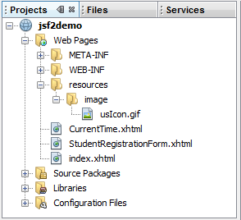

Figure 44.12
The resources folder was created.

<margin note: h:panelGrid>
JSF provides h:panelGrid and h:panelGroup elements to contain and layout subelements. h:panelGrid places the elements in a grid like the Java grid layout manager. h:panelGrid places the elements like a Java GUI flow layout manager. Lines 18-25 places six elements (labels and input texts) are in a h:panelGrid. The columns attribute specifies that each row in the grid has 6 columns. The elements are placed into a row from left to right in the order they appear in the facelet. When a row is full, a new row is created to hold the elements. We used h:panelGrid in this example. You may replace it with h:panelGroup to see how the elements would be arranged.

<margin note: the style attribute>
You may use the style attribute with a JSF html tag to specify the CSS style for the element and its subelements. The style attribute in line 8 specifies color green for all elements in this h:panelGrid element.

<margin note: h:outputLabel>
The h:outputLabel element is for displaying a label (line 19). You can use the value attribute to specify the lable’s text.

<margin note: h:inputText>
The h:inputText element is for displaying a text input box for the user to enter a text (line 20). The id attribute is useful for other elements or the server program to reference this element.

<margin note: h:selectOneRadio>
The h:selectOneRadio element is for displaying a group of radio buttons (line 30). Each radio button is defined using an f:selectItem element (lines 31-34).

<margin note: h:selectOneMenu>
The h:selectOneMenu element is for displaying a combo box (line 41). Each item in the combo box is defined using an f:selectItem element (lines 42-43).

<margin note: h:selectManyListbox>
The h:selectManyListbox element is for displaying a list for the user to choose multiple items in a list (line 46). Each item in the list is defined using an f:selectItem element (lines 47-49).

<margin note: h:selectManyCheckbox>
The h:selectManyCheckbox element is for displaying a group of check boxes (line 56). Each item in the check box is defined using an f:selectItem element (lines 57-59).

<margin note: h:selectTextarea>
The h:selectTextarea element is for displaying a text area for multiple lines of input (line 66). You can use the style attribute to specify the width and height of the text area (line 67).

<margin note: h:selectTextarea>
The h:selectTextarea element is for displaying a text area for multiple lines of input (line 66). The style attribute is used to specify the width and height of the text area (line 67).

<margin note: h:commandButton>
The h:commandButton element is for displaying a button. When the button is clicked, an action is performed. The default action is to request the same page from the server. The next section shows how to process the form.

44.4 Processing the Form
The preceding section introduced how to display a form using common JSF elements. This section shows how to obtain and process the input.

To obtain input from the form, simply bind each input element with a property in a managed bean. We now define a managed bean named Registration as shown in Listing 44.5.

Listing 44.5 Registration.java
<margin note line 6: managed bean>
<margin note line 7: request scope>
<margin note line 9: property lastName>
<margin note line 82: getResponse()>

package jsf2demo;

import javax.faces.bean.ManagedBean;
import javax.faces.bean.RequestScoped;

@ManagedBean
@RequestScoped
public class Registration {
private String lastName;
private String firstName;
private String mi;
private String gender;
private String major;
private String[] minor;
private String[] hobby;
private String remarks;

public String getLastName() {
return lastName;
}

public void setLastName(String lastName) {
this.lastName = lastName;
}

public String getFirstName() {
return firstName;
}

public void setFirstName(String firstName) {
this.firstName = firstName;
}

public String getMi() {
return mi;
}

public void setMi(String mi) {
this.mi = mi;
}

public String getGender() {
return gender;
}

public void setGender(String gender) {
this.gender = gender;
}

public String getMajor() {
return major;
}

public void setMajor(String major) {
this.major = major;
}

public String[] getMinor() {
return minor;
}

public void setMinor(String[] minor) {
this.minor = minor;
}

public String[] getHobby() {
return hobby;
}

public void setHobby(String[] hobby) {
this.hobby = hobby;
}

public String getRemarks() {
return remarks;
}

public void setRemarks(String remarks) {
this.remarks = remarks;
}

public String getResponse() {
if (lastName == null)
return ""; // Request has not been made
else {
String allMinor = "";
for (String s: minor) {
allMinor += s + " ";
}

String allHobby = "";
for (String s: hobby) {
allHobby += s + " ";
}

return "<p style=\"color:red\">You entered <br />" +
"Last Name: " + lastName + "<br />" +
"First Name: " + firstName + "<br />" +
"MI: " + mi + "<br />" +
"Gender: " + gender + "<br />" +
"Major: " + major + "<br />" +
"Minor: " + allMinor + "<br />" +
"Hobby: " + allHobby + "<br />" +
"Remarks: " + remarks + "</p>";
}
}
}

<margin note: bean properties>
The Registration class is a managed bean that defines the properties lastName, firstName, mi, gender, major, minor, and remarks, which will be bound to the elements in the JSF registration form.

The registration form can now be redefined as shown in Listing 44.6. Figure 44.13 shows that new JSF page displays the user input upon clicking the Register button.

Listing 44.6 ProcessStudentRegistrationForm.xhtml
<margin note line 6: jsf core namespace>
<margin note line 21: bind lastName>
<margin note line 24: bind firstName>
<margin note line 27: bind mi>
<margin note line 34: bind gender>
<margin note line 46: bind major>
<margin note line 52: bind minor>
<margin note line 63: bind hobby>
<margin note line 75: bind remarks>
<margin note line 82: bind response>

<?xml version='1.0' encoding='UTF-8' ?>
<!DOCTYPE html PUBLIC "-//W3C//DTD XHTML 1.0 Transitional//EN"
"http://www.w3.org/TR/xhtml1/DTD/xhtml1-transitional.dtd">
<html xmlns="http://www.w3.org/1999/xhtml"
xmlns:h="http://java.sun.com/jsf/html"
xmlns:f="http://java.sun.com/jsf/core">
<h:head>
<title>Student Registration Form</title>
</h:head>
<h:body>
<h:form>
<!-- Use h:graphicImage -->
<h3>Student Registration Form
<h:graphicImage name="usIcon.gif" library="image"/>
</h3>

<!-- Use h:panelGrid -->
<h:panelGrid columns="6" style="color:green">
<h:outputLabel value="Last Name"/>
<h:inputText id="lastNameInputText"
value="#{registration.lastName}"/>
<h:outputLabel value="First Name" />
<h:inputText id="firstNameInputText"
value="#{registration.firstName}"/>
<h:outputLabel value="MI" />
<h:inputText id="miInputText" size="1"
value="#{registration.mi}"/>
</h:panelGrid>

<!-- Use radio buttons -->
<h:panelGrid columns="2">
<h:outputLabel>Gender </h:outputLabel>
<h:selectOneRadio id="genderSelectOneRadio"
value="#{registration.gender}">
<f:selectItem itemValue="Male"
itemLabel="Male"/>
<f:selectItem itemValue="Female"
itemLabel="Female"/>
</h:selectOneRadio>
</h:panelGrid>

<!-- Use combo box and list -->
<h:panelGrid columns="4">
<h:outputLabel value="Major "/>
<h:selectOneMenu id="majorSelectOneMenu"
value="#{registration.major}">
<f:selectItem itemValue="Computer Science"/>
<f:selectItem itemValue="Mathematics"/>
</h:selectOneMenu>
<h:outputLabel value="Minor "/>
<h:selectManyListbox id="minorSelectManyListbox"
value="#{registration.minor}">
<f:selectItem itemValue="Computer Science"/>
<f:selectItem itemValue="Mathematics"/>
<f:selectItem itemValue="English"/>
</h:selectManyListbox>
</h:panelGrid>

<!-- Use check boxes -->
<h:panelGrid columns="4">
<h:outputLabel value="Hobby: "/>
<h:selectManyCheckbox id="hobbySelectManyCheckbox"
value="#{registration.hobby}">
<f:selectItem itemValue="Tennis"/>
<f:selectItem itemValue="Golf"/>
<f:selectItem itemValue="Ping Pong"/>
</h:selectManyCheckbox>
</h:panelGrid>

<!-- Use text area -->
<h:panelGrid columns="1">
<h:outputLabel>Remarks:</h:outputLabel>
<h:inputTextarea id="remarksInputTextarea"
style="width:400px; height:50px;"
value="#{registration.remarks}"/>
</h:panelGrid>

<!-- Use command button -->
<h:commandButton value="Register" />
<br />
<h:outputText escape="false" style="color:red"
value="#{registration.response}" />
</h:form>
</h:body>
</html>

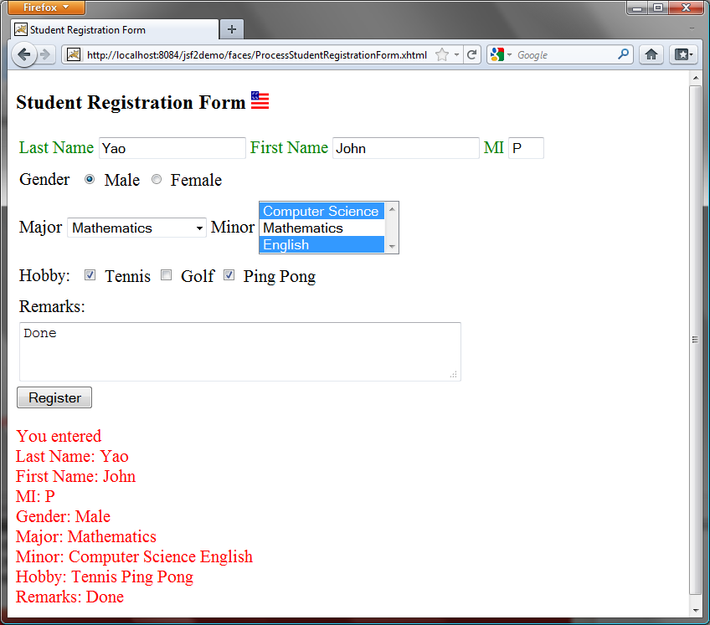

Figure 44.13
The user input is collected and displayed after clicking the Register button.

<margin note: binding input texts>
The new JSF form in this listing binds the h:inputText element for last name, first name, and mi with the properties lastName, firstName, and mi in the managed bean (lines 22, 24, 27). When the Register button is clicked, the page is sent to the server, which invokes the set methods to set the properties in the managed bean.

<margin note: binding radio buttons>
The h:selectOneRadio element is bound to the gender property (line 34). Each radio button has an itemValue. The selected radio button’s itemValue is set to the gender property in the bean when the page is sent to the server.

<margin note: binding combo box>
The h:selectOneMenu element is bound to the major property (line 46). When the page is sent to the server, the selected item is returned as a string and is set to the major property.

<margin note: binding list box>
The h:selectManyListbox element is bound to the minor property (line 52). When the page is sent to the server, the selected items are returned as an array of strings and set to the minor property.

<margin note: binding check boxes>
The h:selectManyCheckbox element is bound to the hobby property (line 63). When the page is sent to the server, the checked boxes are returned as an array of itemValues and set to the hobby property.

<margin note: binding text area>
The h:selectTextarea element is bound to the remarks property (line 75). When the page is sent to the server, the content in the text area is returned as a string and set to the remarks property.

<margin note: binding response>
The h:outputText element is bound to the response property (line 82). This is a read-only property in the bean. It is "" if lastName is null (lines 83-84 in Listing 44.5). When the page is returned to the client, the response property value is displayed in the output text element (line 82).

<margin note: escape attribute>
The h:outputText element’s escape attribute is set to false (line 81) to enable the contents to be displayed in HTML. By default, the escape attribute is true, which indicates the contents are considered as regular text.

44.5 Case Study: Calculator
This section uses JSF to develop a calculator to perform addition, subtraction, multiplication, and division, as shown in Figure 44.21.

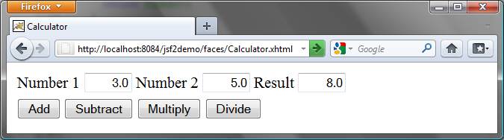
Figure 44.21
This JSF application enables you to perform addition, subtraction, multiplication, and division.

Here are the steps to develop this project:

<margin note: create managed bean>
Step 1. Create a new managed bean named Calculator with the request scope as shown in Listing 44.7, Calculator.java.
<margin note: create JSF facelet>
Step 2. Create a JSP facelet named Calculator as shown in Listing 44.8, Calculator.xhtml.

Listing 44.7 Calculator.java
<margin note line 9: property number1>
<margin note line 10: property number2>
<margin note line 11: property result>
<margin note line 40: add>
<margin note line 44: subtract>
<margin note line 48: divide>
<margin note line 52: multiply>

package jsf2demo;

import javax.faces.bean.ManagedBean;
import javax.faces.bean.RequestScoped;

@ManagedBean
@RequestScoped
public class Calculator {
private Double number1;
private Double number2;
private Double result;

public Calculator() {
}

public Double getNumber1() {
return number1;
}

public Double getNumber2() {
return number2;
}

public Double getResult() {
return result;
}

public void setNumber1(Double number1) {
this.number1 = number1;
}

public void setNumber2(Double number2) {
this.number2 = number2;
}

public void setResult(Double result) {
this.result = result;
}

public void add() {
result = number1 + number2;
}

public void subtract() {
result = number1 - number2;
}

public void divide() {
result = number1 / number2;
}

public void multiply() {
result = number1 * number2;
}
}

The managed bean has three properties number1, number2, and result (lines 9-38). The methods add(), subtract(), divide(), and multiply() add, subtract, multiply, and divide number1 with number2 and assigns the result to result (lines 40-54).

Listing 44.8 Calculator.xhtml
<margin note line 14: right align>
<margin note line 15: bind text input>
<margin note line 28: action>

<?xml version='1.0' encoding='UTF-8' ?>
<!DOCTYPE html PUBLIC "-//W3C//DTD XHTML 1.0 Transitional//EN"
"http://www.w3.org/TR/xhtml1/DTD/xhtml1-transitional.dtd">
<html xmlns="http://www.w3.org/1999/xhtml"
xmlns:h="http://java.sun.com/jsf/html">
<h:head>
<title>Calculator</title>
</h:head>
<h:body>
<h:form>
<h:panelGrid columns="6">
<h:outputLabel value="Number 1"/>
<h:inputText id="number1InputText" size ="4"
style="text-align: right"
value="#{calculator.number1}"/>
<h:outputLabel value="Number 2" />
<h:inputText id="number2InputText" size ="4"
style="text-align: right"
value="#{calculator.number2}"/>
<h:outputLabel value="Result" />
<h:inputText id="resultInputText" size ="4"
style="text-align: right"
value="#{calculator.result}"/>
</h:panelGrid>

<h:panelGrid columns="4">
<h:commandButton value="Add"
action ="#{calculator.add}"/>
<h:commandButton value="Subtract"
action ="#{calculator.subtract}"/>
<h:commandButton value="Multiply"
action ="#{calculator.multiply}"/>
<h:commandButton value="Divide"
action ="#{calculator.divide}"/>
</h:panelGrid>
</h:form>
</h:body>
</html>

Three text input components along with their labels are placed in the grid panel (lines 11-24). Four button components are placed in the grid panel (lines 26-35).

The bean property number1 is bound to the text input for Number 1 (line 15). The CSS style text-align: right (line 14) specifies that the text is right-aligned in the input box.

The action attribute for the Add button is set to the add method in the calculator bean (line 28). When the Add button is clicked, the add method in the bean is invoked to add number1 with number2 and assign the result to result. Since the result property is bound the Result input text, the new result is now displayed in the text input field.

44.6 Session Tracking
Chapter 43, “JSP,” introduced session tracking using JavaBeans by sharing the JavaBeans objects among different pages. You can specify the JavaBeans objects at the application scope, session scope, page scope, or request scope. JSF supports session tracking using JavaBeans at the application scope, session scope, and request scope. Additionally, JSF 2.0 supports the view scope, which keeps the bean alive as long as you stay on the view. The view scope is between session and request scopes.

Consider the following example that prompts the user to guess a number. When the page starts, the program randomly generates a number between 0 and 99. This number is stored in the session. When the user enters a guess, the program checks the guess with the random number in the session and tells the user whether the guess is too high, too low, or just right, as shown in Figure 44.14.

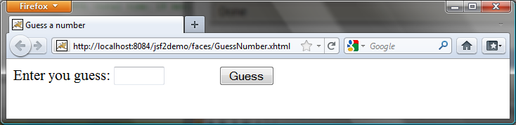

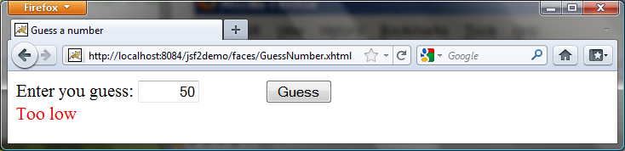

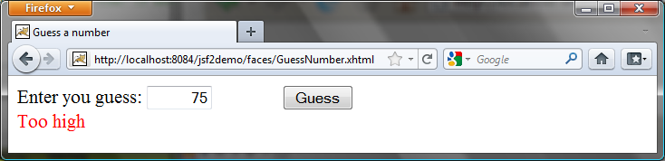

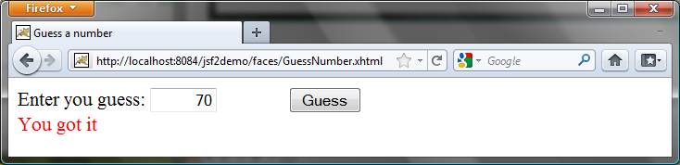

Figure 44.14
The user enters a guess and the program displays the result.

Here are the steps to develop this project:

<margin note: create managed bean>
Step 1. Create a new managed bean named GuessNumber with the view scope as shown in Listing 44.9, GuessNumber.java.
<margin note: create JSF facelet>
Step 2. Create a JSP facelet named GuessNumber as shown in Listing 44.10, GuessNumber.xhtml.

Listing 44.9 GuessNumber.java
<margin note line 7: view scope>
<margin note line 9: random number>
<margin note line 10: guess by user>
<margin note line 13: create random number>
<margin note line 16: get method>
<margin note line 20: set method>
<margin note line 24: get response>
<margin note line 28: check guess>

package jsf2demo;

import javax.faces.bean.ManagedBean;
import javax.faces.bean.ViewScoped;

@ManagedBean
@ViewScoped
public class GuessNumber {
private int number;
private String guessString;

public GuessNumber() {
number = (int)(Math.random() * 100);
}

public String getGuessString() {
return guessString;
}

public void setGuessString(String guessString) {
this.guessString = guessString;
}

public String getResponse() {
if (guessString == null)
return ""; // No user input yet

int guess = Integer.parseInt(guessString);
if (guess < number)
return "Too low";
else if (guess == number)
return "You got it";
else
return "Too high";
}
}

The managed bean uses the @ViewScope annotation (line 5) to set up the view scope for the bean. The view scope is most appropriate for this project. The bean is alive as long as the view is not changed. The bean is created when the page is displayed for the first time. A random number between 0 and 99 is assigned to number (line 13) when the bean is created. This number will not change as long as the bean is alive.

The getResponse method converts guessString from the user input to an integer (line 28) and determines if the guess is too low (line 30), too high (line 34), and just right (line 32).

Listing 44.10 GuessNumber.xhtml
<margin note line 14: bind text input>
<margin note line 18: bind text output>

<?xml version='1.0' encoding='UTF-8' ?>
<!DOCTYPE html PUBLIC "-//W3C//DTD XHTML 1.0 Transitional//EN"
"http://www.w3.org/TR/xhtml1/DTD/xhtml1-transitional.dtd">
<html xmlns="http://www.w3.org/1999/xhtml"
xmlns:h="http://java.sun.com/jsf/html">
<h:head>
<title>Guess a number</title>
</h:head>
<h:body>
<h:form>
<h:outputLabel value="Enter you guess: "/>
<h:inputText style="text-align: right; width: 50px"
id="guessInputText"
value="#{guessNumber.guessString}"/>
<h:commandButton style="margin-left: 60px" value="Guess" />
<br />
<h:outputText style="color: red"
value="#{guessNumber.response}" />
</h:form>
</h:body>
</html>

The bean property guessString is bound to the text input (line 14). The CSS style text-align: right (line 13) specifies that the text is right-aligned in the input box.

The CSS style margin-left: 60px (line 15) specifies that the command button has a left margin of 60 pixels.

The bean property response is bound to the text output (line 18). The CSS style color: red (line 17) specifies that the text is displayed in red in the output box.

<margin note: scope>
The project uses the view scope. What happens if the scope is changed to the request scope? Every time the page is refreshed, JSF creates a new bean with a new random number. What happens if the scope is changed to the session scope? The bean will be alive as long as the browser is alive. What happens if the scope is changed to the application scope? The bean will be created once when the application is launched from the server.

44.7 Validating Input
In the preceding GuessNumber page, an error would occur if you entered a non-integer in the input box before clicking the Guess button. A simple way to fix the problem is to check the text field before processing any event. JSF provides several convenient and powerful ways for input validation. You can use the standard validator tags in the JSF Core Tag Library or create custom validators. Table 44.2 lists some JSF input validator tags.

Table 44.2
JSF Input Validator Tags
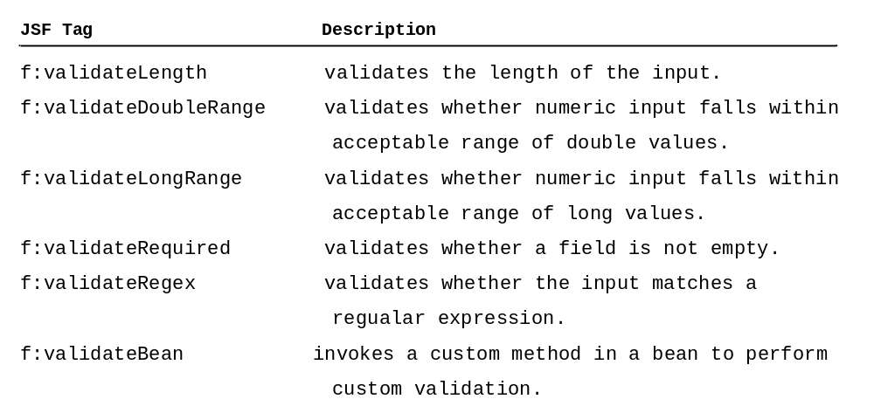

Consider the following example that displays a form for collecting user input as shown in Figure 44.15. All text fields in the form must be filled. If not, error messages are displayed. The SSN must be formatted corrected. If not, an error is displayed. If all input is correct, clicking Submit displays the result in an output text, as shown in Figure 44.16.

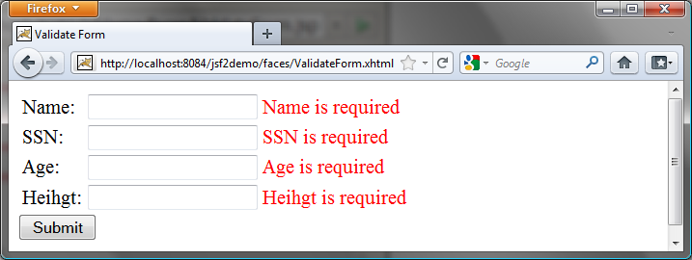
(a) The required messages are displayed if input is required, but empty.

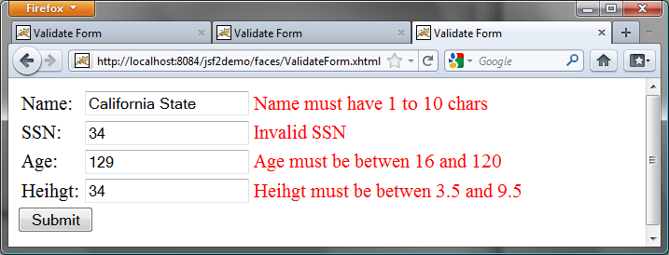
(b) Error messages are displayed if input is incorrect.

Figure 44.15
The input fields are validated.

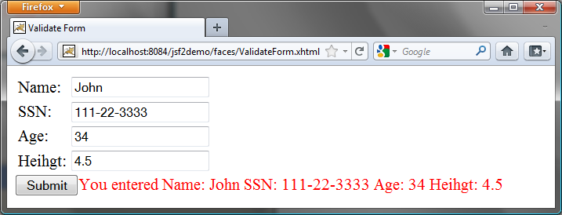

Figure 44.16
The correct input values are displayed.

Here are the steps to create this project.
Step 1. Create a new page named ValidateForm, as shown in Listing 44.11.
Step 2. Create a new managed bean named ValidateForm, as shown in Listing 44.12.

Listing 44.11 ValidateForm.xhtml
<margin note line 14: required input>
<margin note line 15: required message>
<margin note line 16: validator message>
<margin note line 18: validate length>
<margin note line 20: message element>
<margin note line 27: validate regex>
<margin note line 36: validate integer range>
<margin note line 45: validate double range>

<?xml version='1.0' encoding='UTF-8' ?>
<!DOCTYPE html PUBLIC "-//W3C//DTD XHTML 1.0 Transitional//EN"
"http://www.w3.org/TR/xhtml1/DTD/xhtml1-transitional.dtd">
<html xmlns="http://www.w3.org/1999/xhtml"
xmlns:h="http://java.sun.com/jsf/html"
xmlns:f="http://java.sun.com/jsf/core">
<h:head>
<title>Validate Form</title>
</h:head>
<h:body>
<h:form>
<h:panelGrid columns="3">
<h:outputLabel value="Name:"/>
<h:inputText id="nameInputText" required="true"
requiredMessage="Name is required"
validatorMessage="Name must have 1 to 10 chars"
value="#{validateForm.name}">
<f:validateLength minimum="1" maximum="10" />
</h:inputText>
<h:message for="nameInputText" style="color:red"/>

<h:outputLabel value="SSN:" />
<h:inputText id="ssnInputText" required="true"
requiredMessage="SSN is required"
validatorMessage="Invalid SSN"
value="#{validateForm.ssn}">
<f:validateRegex pattern="[\d]{3}-[\d]{2}-[\d]{4}"/>
</h:inputText>
<h:message for="ssnInputText" style="color:red"/>

<h:outputLabel value="Age:" />
<h:inputText id="ageInputText" required="true"
requiredMessage="Age is required"
validatorMessage="Age must be betwen 16 and 120"
value="#{validateForm.ageString}">
<f:validateLongRange minimum="16" maximum="120"/>
</h:inputText>
<h:message for="ageInputText" style="color:red"/>

<h:outputLabel value="Heihgt:" />
<h:inputText id="heightInputText" required="true"
requiredMessage="Heihgt is required"
validatorMessage="Heihgt must be betwen 3.5 and 9.5"
value="#{validateForm.heightString}">
<f:validateDoubleRange minimum="3.5" maximum="9.5"/>
</h:inputText>
<h:message for="heightInputText" style="color:red"/>
</h:panelGrid>

<h:commandButton value="Submit" />

<h:outputText style="color:red"
value="#{validateForm.response}" />
</h:form>
</h:body>
</html>

<margin note: required attribute>
<margin note: requiredMessage>
For each input text field, set its required attribute true (line 14) to indicate that an input value is required for the field. When a required input field is empty, the requiredMessage is displayed (line 15).

<margin note: validatorMessage>
<margin note: f:validateLength>
The validatorMessage attribute specifies a message to be displayed if the input field is invalid (line 16). The f:validateLength tag specifies the minimum or maximum length of the input (line 18). JSF will determine whether the input length is valid.

<margin note: h:message>
The h:message element displays the validatorMessage if the input is invalid. The element’s for attribute specifies the id of the element for which the message will be displayed (line 20).

<margin note: f:validateRegex>
The f:validateRegex tag specifies a regular expression for validating the input (line 27). For information on regular expression, see Supplement III.H.

<margin note: f:validateLongRange>
The f:validateLongRange tag specifies a range for an integer input using the minimum and maximum attribute (line 36). In this project, a valid age value is between 16 and 120.

<margin note: f:validateDoubleRange>
The f:validateDoubleRange tag specifies a range for a double input using the minimum and maximum attribute (line 36). In this project, a valid height value is between 3.5 and 9.5.

Listing 44.12 ValidateForm.java
<margin note line 49: some input not set>

package jsf2demo;

import javax.faces.bean.ManagedBean;
import javax.faces.bean.RequestScoped;

@ManagedBean
@RequestScoped
public class ValidateForm {
private String name;
private String ssn;
private String ageString;
private String heightString;

public String getName() {
return name;
}

public void setName(String name) {
this.name = name;
}

public String getSsn() {
return ssn;
}

public void setSsn(String ssn) {
this.ssn = ssn;
}

public String getAgeString() {
return ageString;
}

public void setAgeString(String ageString) {
this.ageString = ageString;
}

public String getHeightString() {
return heightString;
}

public void setHeightString(String heightString) {
this.heightString = heightString;
}

public String getResponse() {
if (name == null || ssn == null || ageString == null
|| heightString == null) {
return "";
}
else {
return "You entered " +
" Name: " + name +
" SSN: " + ssn +
" Age: " + ageString +
" Heihgt: " + heightString;
}
}
}

If an input is invalid, its value is not set to the bean. So only when all input are correct, the getResponse() method will return all input values (lines 46-58)

41.8 Binding Database with Facelets
Often you need to access database from a Web page. This section gives examples of building Web applications using databases.

Consider the following example that lets the user choose a course, as shown in Figure 44.17. After a course is selected in the drop down list, the students enrolled in the course are displayed in the table, as shown in Figure 41.18. In this example, all the course titles in the Course table are bound to the combo box and the query result for the students enrolled in the course is bound to the table.

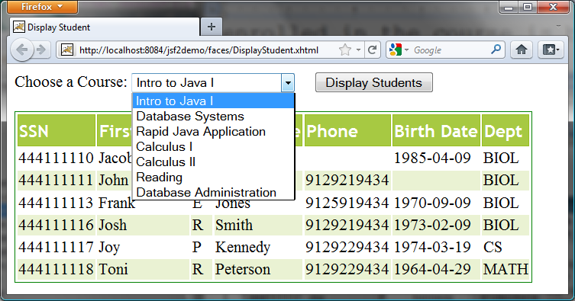

Figure 44.17
You need to choose a course and display the students enrolled in the course.

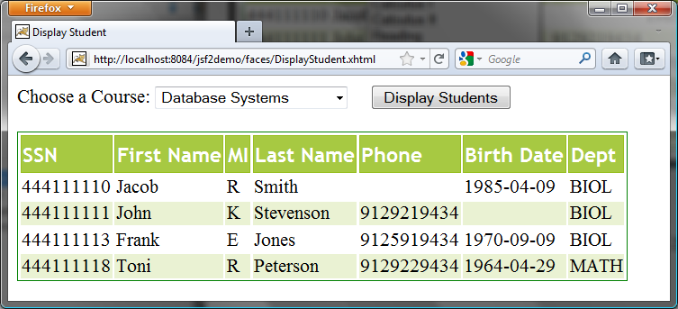

Figure 44.18
The table displays the students enrolled in the course.

Here are the steps to create this project:

<margin note: Managed bean>
Step 1. Create a managed bean named CourseName with application scope, as shown in Listing 44.13.
<margin note: JSF page>
Step 2. Create a JSP page named DisplayStudent, as shown in Listing 44.14.
<margin note: style sheet>
Step 3. Create a cascading style sheet for formatting the table as follows:

Step 3.1. Right-click the resources node to choose New, Others to display the New File dialog box, as shown in Figure 44.19.
Step 3.2. Choose Other in the Categories section and Cascading Style Sheet in the File Types section to display the New Cascading Style Sheet dialog box, as shown in Figure 44.20.
Step 3.3. Enter tablestyle as the File Name and click Finish to create tablestyle.css under the resources node.
Step 3.4. Define the CSS style as shown in Listing 44.15.

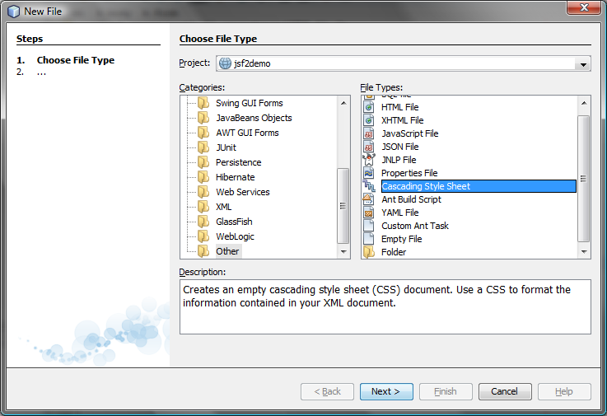
Figure 44.19
You can create CSS files for Web project in NetBenas.

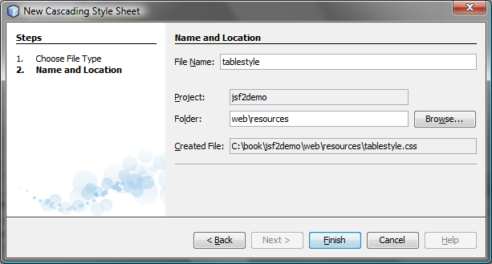

Figure 44.20
The New Cascading Style Sheet dialog box creates a new style sheet file.

Listing 44.13 CourseName.java
<margin note line 9: application scope>
<margin note line 18: initialize JDBC>
<margin note line 27: connect to database>
<margin note line 32: get course titles>
<margin note line 34: execute SQL>
<margin note line 39: titles array>
<margin note line 72: get student>
<margin note line 77: set a course>
<margin note line 83: get rowset>

package jsf2demo;

import javax.faces.bean.ManagedBean;
import javax.faces.bean.ApplicationScoped;
import java.sql.*;
import javax.sql.rowset.CachedRowSet;

@ManagedBean
@ApplicationScoped
public class CourseName {
private PreparedStatement studentStatement = null;
private CachedRowSet rowSet; // For course titles
private String choice; // Selected course
private String[] titles; // Course titles

/** Creates a new instance of CourseName */
public CourseName() {
initializeJdbc();
}

/** Initialize database connection */
private void initializeJdbc() {
try {
Class.forName("com.mysql.jdbc.Driver");

// Connect to the sample database
Connection connection = DriverManager.getConnection(
"jdbc:mysql://localhost/javabook", "scott", "tiger");

// Get course titles
PreparedStatement statement = connection.prepareStatement(
"select title from course");
rowSet = new com.sun.rowset.CachedRowSetImpl();
rowSet.populate(statement.executeQuery());
titles = new String[rowSet.size()];
int i = 0;
try {
while (rowSet.next()) {
titles[i++] = rowSet.getString(1);
}
} catch (Exception ex) {
ex.printStackTrace();
}

// Define a SQL statement for getting students
studentStatement = connection.prepareStatement(
"select Student.ssn, "
+ "student.firstName, Student.mi, Student.lastName, "
+ "Student.phone, Student.birthDate, Student.street, "
+ "Student.zipCode, Student.deptId "
+ "from Student, Enrollment, Course "
+ "where Course.title = ? "
+ "and Student.ssn = Enrollment.ssn "
+ "and Enrollment.courseId = Course.courseId;");
} catch (Exception ex) {
ex.printStackTrace();
}
}

public String[] getTitles() {
return titles;
}

public String getChoice() {
return choice;
}

public void setChoice(String choice) {
this.choice = choice;
}

public ResultSet getStudents() throws SQLException {
if (choice == null) {
if (titles == null)
return null;
else
studentStatement.setString(1, titles[0]);
} else {
studentStatement.setString(1, choice); // Set course title
}

// Get students for the specified course
CachedRowSet rowSet = new com.sun.rowset.CachedRowSetImpl();
rowSet.populate(studentStatement.executeQuery());
return rowSet;
}
}

We use the same MySQL database javabook created in Chapter 33, “Java Database Programming.” The scope for this managed bean is application. The bean is created when the project is launched from the server. The database connection is created once in the bean’s constructor (lines 17-19). The initializeJdbc method loads the JDBC driver for MySQL (line 24), connects to the MySQL database (lines 25-26), creates statement for obtaining course titles (lines 29-30), and creates a statement for obtaining the student information for the specified course (lines 44-52). Lines 31-41 execute the statement for obtaining course titles and store them in array titles.

The getStudents() method returns a ResultSet that consists of all students enrolled in the specified course (lines 70-84). The choice for the title is set in the statement to obtain the student for the specified title (line 77). If choice is null, the first title in the titles array is set in the statement (line 77). If titles is null, getStudents() returns null (line 73).

Listing 44.14 DisplayStudent.xhtml
<margin note line 9: style sheet>
<margin note line 14: bind choice>
<margin note line 15: titles>
<margin note line 18: display button>
<margin note line 22: bind result set>
<margin note line 23: rowClasses>
<margin note line 24: headerClass>
<margin note line 25: styleClass>
<margin note line 28: ssn column>
<margin note line 33: firstName column>
<margin note line 38: mi column>
<margin note line 43: lastName column>
<margin note line 48: phone column>
<margin note line 53: birthDate column>
<margin note line 58: deptId column>

<?xml version='1.0' encoding='UTF-8' ?>
<!DOCTYPE html PUBLIC "-//W3C//DTD XHTML 1.0 Transitional//EN"
"http://www.w3.org/TR/xhtml1/DTD/xhtml1-transitional.dtd">
<html xmlns="http://www.w3.org/1999/xhtml"
xmlns:h="http://java.sun.com/jsf/html"
xmlns:f="http://java.sun.com/jsf/core">
<h:head>
<title>Display Student</title>
<h:outputStylesheet name="tablestyle.css"/>
</h:head>
<h:body>
<h:form>
<h:outputLabel value="Choose a Course: " />
<h:selectOneMenu value="#{courseName.choice}">
<f:selectItems value="#{courseName.titles}" />
</h:selectOneMenu>

<h:commandButton style="margin-left: 20px"
value="Display Students" />

<br /> <br />
<h:dataTable value="#{courseName.students}" var="student"
rowClasses="oddTableRow, evenTableRow"
headerClass="tableHeader"
styleClass="table">
<h:column>
<f:facet name="header">SSN</f:facet>
#{student.ssn}
</h:column>

<h:column>
<f:facet name="header">First Name</f:facet>
#{student.firstName}
</h:column>

<h:column>
<f:facet name="header">MI</f:facet>
#{student.mi}
</h:column>

<h:column>
<f:facet name="header">Last Name</f:facet>
#{student.lastName}
</h:column>

<h:column>
<f:facet name="header">Phone</f:facet>
#{student.phone}
</h:column>

<h:column>
<f:facet name="header">Birth Date</f:facet>
#{student.birthDate}
</h:column>

<h:column>
<f:facet name="header">Dept</f:facet>
#{student.deptId}
</h:column>
</h:dataTable>
</h:form>
</h:body>
</html>

Line 9 specifies that the style sheet tablestyle.css created in Step 3 is used in this XMTHL file. The rowClasses = "oddTableRow, evenTableRow" attribute specifies the style applied to the rows alternately using oddTableRow and evenTableRow (line 23). The headerClasses = "tableHeader" attribute specifies that the tableHeader class is used for header style (line 24). The styleClasses = "table" attribute specifies that the table class is used for the style of all other elements in the table (line 25).

Line 14 binds the choice property in the courseName bean with the combo box. The selection values in the combo box are bound with the titles array property (line 15).

Line 22 binds the table value with a database result set using the attribute value="#{courseName.students}". The var="student" attribute associates a row in the result set with student. Lines 26-59 specify the column values using student.ssn (line 28), student.firstName (line 33), student.mi (line 38), student.lastName (line 33), student.phone (line 48), student.birthDate (line 53), and student.deptId (line 58).

Listing 44.15 tablestyle.css
<margin note line 2: tableHeader>
<margin note line 14: oddTableRow>
<margin note line 18: evenTableRow>
<margin note line 28: table>

/* Style for table */
.tableHeader {
font-family:"Trebuchet MS", Arial, Helvetica, sans-serif;
border-collapse:collapse;
font-size:1.1em;
text-align:left;
padding-top:5px;
padding-bottom:4px;
background-color:#A7C942;
color:white;
border:1px solid #98bf21;
}

.oddTableRow {
border:1px solid #98bf21;
}

.evenTableRow {
background-color: #eeeeee;
font-size:1em;

padding:3px 7px 2px 7px;

color:#000000;
background-color:#EAF2D3;
}

.table {
border:1px solid green;
}

The style sheet file defines the style classes tableHeader (line 2) for table header style, oddTableRow for odd table rows (line 14), evenTableRow for even table rows (line 18), and table for all other table elements (line 28).

41.9 Opening New JSF Pages
All the examples you have seen so far use only one JSF page in a project. Suppose you want to register student information to the database. The application first displays the page as shown in Figure 44.21 to collection student information. After the user enters the information and clicks the Submit button, a new page is displayed to ask the user to confirm the input, as shown in Figure 44.22. If the user clicks the Confirm button, the data is stored into the database and the status page is displayed, as shown in Figure 44.23. If the user clicks the Go Back button, it goes back to the first page.

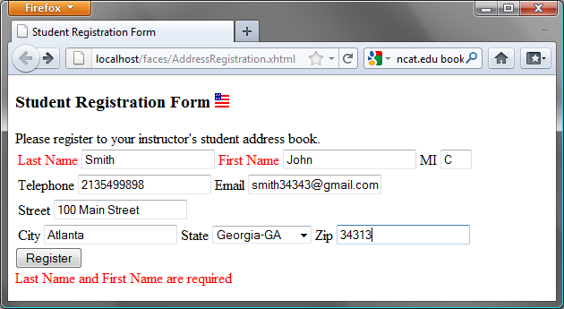
Figure 44.21
This page lets the user enter input.

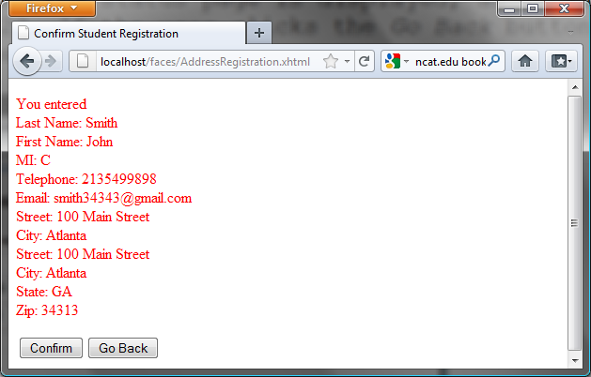
Figure 44.22
This page lets the user confirm the input.

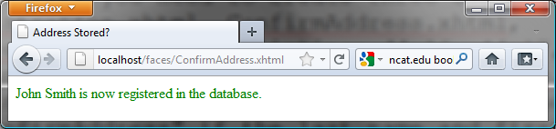
Figure 44.23
This page displays the status of the user input.

For this project, you need to create three JSP pages named AddressRegistration.xhtml, ConfirmAddress.xhtml, AddressStoredStatus.xhtml in Listings 44.16, 44.17, and 44.18. The project starts with AddressRegistration.xhtml. When clicking the Submit button, the action for the button returns "ConfirmAddress" if the last name and first name are not empty, which causes ConfirmAddress.xhtml to be displayed. When clicking the Confirm button, the status page AddressStoredStatus is displayed. When clicking the Go Back button, the first page AddressRegistration is now displayed.

Listing 44.16 AddressRegistration.xhmtl
<margin note line 6: jsf core namespace>
<margin note line 22: bind lastName>
<margin note line 25: bind firstName>
<margin note line 28: bind mi>
<margin note line 34: bind telephone>
<margin note line 37: bind email>
<margin note line 43: bind street>
<margin note line 49: bind city>
<margin note line 52: bind state>
<margin note line 59: bind zip>
<margin note line 64: process register>

<?xml version='1.0' encoding='UTF-8' ?>
<!DOCTYPE html PUBLIC "-//W3C//DTD XHTML 1.0 Transitional//EN"
"http://www.w3.org/TR/xhtml1/DTD/xhtml1-transitional.dtd">
<html xmlns="http://www.w3.org/1999/xhtml"
xmlns:h="http://java.sun.com/jsf/html"
xmlns:f="http://java.sun.com/jsf/core">
<h:head>
<title>Student Registration Form</title>
</h:head>
<h:body>
<h:form>
<!-- Use h:graphicImage -->
<h3>Student Registration Form
<h:graphicImage name="usIcon.gif" library="image"/>
</h3>

Please register to your instructor's student address book.
<!-- Use h:panelGrid -->
<h:panelGrid columns="6">
<h:outputLabel value="Last Name" style="color:red"/>
<h:inputText id="lastNameInputText"
value="#{addressRegistration.lastName}"/>
<h:outputLabel value="First Name" style="color:red"/>
<h:inputText id="firstNameInputText"
value="#{addressRegistration.firstName}"/>
<h:outputLabel value="MI" />
<h:inputText id="miInputText" size="1"
value="#{addressRegistration.mi}"/>
</h:panelGrid>

<h:panelGrid columns="4">
<h:outputLabel value="Telephone"/>
<h:inputText id="telephoneInputText"
value="#{addressRegistration.telephone}"/>
<h:outputLabel value="Email"/>
<h:inputText id="emailInputText"
value="#{addressRegistration.email}"/>
</h:panelGrid>

<h:panelGrid columns="4">
<h:outputLabel value="Street"/>
<h:inputText id="streetInputText"
value="#{addressRegistration.street}"/>
</h:panelGrid>

<h:panelGrid columns="6">
<h:outputLabel value="City"/>
<h:inputText id="cityInputText"
value="#{addressRegistration.city}"/>
<h:outputLabel value="State"/>
<h:selectOneMenu id="stateSelectOneMenu"
value="#{addressRegistration.state}">
<f:selectItem itemLabel="Georgia-GA" itemValue="GA" />
<f:selectItem itemLabel="Oklahoma-OK" itemValue="OK" />
<f:selectItem itemLabel="Indiana-IN" itemValue="IN"/>
</h:selectOneMenu>
<h:outputLabel value="Zip"/>
<h:inputText id="zipInputText"
value="#{addressRegistration.zip}"/>
</h:panelGrid>

<!-- Use command button -->
<h:commandButton value="Register"
action="#{addressRegistration.processSubmit()}"/>
<br />
<h:outputText escape="false" style="color:red"
value="#{addressRegistration.requiredFields}" />
</h:form>
</h:body>
</html>

Listing 44.17 ConfirmAddress.xhmtl
<margin note line 15: process confirm>
<margin note line 17: go to AddressRegistration page>

<?xml version='1.0' encoding='UTF-8' ?>
<!DOCTYPE html PUBLIC "-//W3C//DTD XHTML 1.0 Transitional//EN"
"http://www.w3.org/TR/xhtml1/DTD/xhtml1-transitional.dtd">
<html xmlns="http://www.w3.org/1999/xhtml"
xmlns:h="http://java.sun.com/jsf/html">
<h:head>
<title>Confirm Student Registration</title>
</h:head>
<h:body>
<h:form>
<h:outputText escape="false" style="color:red"
value="#{registration1.input}" />
<h:panelGrid columns="2">
<h:commandButton value="Confirm"
action = "#{registration1.storeStudent()}"/>
<h:commandButton value="Go Back"
action = "StudentRegistration"/>
</h:panelGrid>
</h:form>
</h:body>
</html>

Listing 44.18 AddressStoredStatus.xhmtl
***PD: Please add line numbers in the following code***
***Layout: Please layout exactly. Don’t skip the space. This is true for all source code in the book. Thanks, AU.
<margin note line 12: display status>

<?xml version='1.0' encoding='UTF-8' ?>
<!DOCTYPE html PUBLIC "-//W3C//DTD XHTML 1.0 Transitional//EN"
"http://www.w3.org/TR/xhtml1/DTD/xhtml1-transitional.dtd">
<html xmlns="http://www.w3.org/1999/xhtml"
xmlns:h="http://java.sun.com/jsf/html">
<h:head>
<title>Address Stored?</title>
</h:head>
<h:body>
<h:form>
<h:outputText escape="false" style="color:green"
value="#{registration1.status}" />
</h:form>
</h:body>
</html>

Listing 44.19 AddressRegistration.java
<margin note line 7: managed bean>
<margin note line 8: session scope>
<margin note line 10: property lastName>
<margin note line 24: initialize database>
<margin note line 107: go to a new page>
<margin note line 113: check required fields>
<margin note line 121: get input>
<margin note line 157: store address>
<margin note line 169: update status>
<margin note line 175: go to a new page>

package jsf2demo;

import javax.faces.bean.ManagedBean;
import javax.faces.bean.SessionScoped;
import java.sql.*;

@ManagedBean
@SessionScoped
public class AddressRegistration {
private String lastName;
private String firstName;
private String mi;
private String telephone;
private String email;
private String street;
private String city;
private String state;
private String zip;
private String status = "Nothing stored";
// Use a prepared statement to store a student into the database
private PreparedStatement pstmt;

public AddressRegistration() {
initializeJdbc();
}

public String getLastName() {
return lastName;
}

public void setLastName(String lastName) {
this.lastName = lastName;
}

public String getFirstName() {
return firstName;
}

public void setFirstName(String firstName) {
this.firstName = firstName;
}

public String getMi() {
return mi;
}

public void setMi(String mi) {
this.mi = mi;
}

public String getTelephone() {
return telephone;
}

public void setTelephone(String telephone) {
this.telephone = telephone;
}

public String getEmail() {
return email;
}

public void setEmail(String email) {
this.email = email;
}

public String getStreet() {
return street;
}

public void setStreet(String street) {
this.street = street;
}

public String getCity() {
return city;
}

public void setCity(String city) {
this.city = city;
}

public String getState() {
return state;
}

public void setState(String state) {
this.state = state;
}

public String getZip() {
return zip;
}

public void setZip(String zip) {
this.zip = zip;
}

private boolean isRquiredFieldsFilled() {
return !(lastName == null || firstName == null
|| lastName.trim().length() == 0
|| firstName.trim().length() == 0);
}

public String processSubmit() {
if (isRquiredFieldsFilled()) {
return "ConfirmAddress";
} else {
return "";
}
}

public String getRequiredFields() {
if (isRquiredFieldsFilled()) {
return "";
} else {
return "Last Name and First Name are required";
}
}

public String getInput() {
return "<p style=\"color:red\">You entered <br />"
+ "Last Name: " + lastName + "<br />"
+ "First Name: " + firstName + "<br />"
+ "MI: " + mi + "<br />"
+ "Telephone: " + telephone + "<br />"
+ "Email: " + email + "<br />"
+ "Street: " + street + "<br />"
+ "City: " + city + "<br />"
+ "Street: " + street + "<br />"
+ "City: " + city + "<br />"
+ "State: " + state + "<br />"
+ "Zip: " + zip + "</p>";
}

/** Initialize database connection */
private void initializeJdbc() {
try {
// Explicitly load a MySQL driver
Class.forName("com.mysql.jdbc.Driver");
System.out.println("Driver loaded");

// Establish a connection
Connection conn = DriverManager.getConnection(
"jdbc:mysql://localhost/javabook", "scott", "tiger");

// Create a Statement
pstmt = conn.prepareStatement("insert into Address (lastName,"
+ " firstName, mi, telephone, email, street, city, "
+ "state, zip) values (?, ?, ?, ?, ?, ?, ?, ?, ?)");
} catch (Exception ex) {
System.out.println(ex);
}
}

/** Store an address to the database */
public String storeStudent() {
try {
pstmt.setString(1, lastName);
pstmt.setString(2, firstName);
pstmt.setString(3, mi);
pstmt.setString(4, telephone);
pstmt.setString(5, email);
pstmt.setString(6, street);
pstmt.setString(7, city);
pstmt.setString(8, state);
pstmt.setString(9, zip);
pstmt.executeUpdate();
status = firstName + " " + lastName
+ " is now registered in the database.";
} catch (Exception ex) {
status = ex.getMessage();
}

return "AddressStoredStatus";
}

public String getStatus() {
return status;
}
}

The action for the Register button in the AddressRegistration JSF page is processSubmit() (line 64 in AddressRegistration.xhtml). This method checks if last name and first name are not empty (lines 105-111 in AddressRegistration.java). If so, it returns a string "ConfirmAddress", which causes the ConfirmAddress JSF page to be displayed.

The ConfirmAddress JSF page displays the data entered from the user (line 12 in ConfirmAddress.xhtml). The getInput() method (lines 121-134 in AddressRegistration.java) collects the input.

The action for the Confirm button in the ConfirmAddress JSF page is storeStudent() (line 15 in ConfirmAddress.xhtml). This method stores the address in the database (lines 157-176 in AddressRegistration.java) and returns a string "AddressStoredStatus", which causes the AddressStoredStatus page to be displayed. The status message is displayed in this page (line 12 in AddressStoredStatus.xhtml).

The action for the Go Back button in the ConfirmAddress page is "AddressRegistration" (line 17 in ConfirmAddress.xhtml). This causes the AddressRegistration page to be displayed for the user to reenter the input.

The scope of the managed bean is session (line 8 AddressRegistration.java) so the multiple pages can share the same bean.

Note that this program loads the database driver explicitly (line 140 AddressRegistration.java). Sometimes, an IDE such as NetBeans is not able to find a suitable driver. Loading a driver explicitly can avoid this problem.

Chapter Summary
- JSF enables you to completely separate Java code from HTML.
- A facelet is an XHTML page that mixes JSF tags with XHTML tags.
- JSF applications are developed using the Model-View-Controller (MVC) architecture, which separates the application’s data (contained in the model) from the graphical presentation (the view).
- The controller is the JSF framework that is responsible for coordinating interactions between view and the model.
- In JSF, the facelets are the view for presenting data. Data are obtained from Java objects. Objects are defined using Java classes.
- In JSF, the objects that are accessed from a facelet are JavaBeans objects.
- The JSF expression can either use the property name or invoke the method to obtain the current time.
- JSF provides many elements for displaying GUI components. The tags with the h prefix are in the JSF HTML Tag library. The tags with the f prefix are in the JSF Core Tag library.
- You can specify the JavaBeans objects at the application scope, session scope, page scope, view scope, or request scope.
- The view scope keeps the bean alive as long as you stay on the view. The view scope is between session and request scopes.
- JSF provides several convenient and powerful ways for input validation. You can use the standard validator tags in the JSF Core Tag Library or create custom validators.

Test Questions
Do the test questions for this chapter online at www.cs.armstrong.edu/liang/intro9e/test.html.

Review Questions
Section 44.2
44.1 What is JSF?

44.2 How do you create a JSF project in NetBeans?

44.3 How do you create a JSF page in a JSF project?

44.4 What is a facelet?

44.5 What is the file extension name for a facelet?

44.6 What is a managed bean?

44.7 What is the @ManagedBean annotation for?

44.8 What is the @RequestScope annotation for?

44.9 What is the name space for JSF tags with prefix h and prefix f?

Sections 44.3-44.5

44.10 Describe the use of the following tags?

h:form, h:panelGroup, h:panelGrid, h:inputText, h:outputText, h:inputTextArea, h:inputSecret, h:outputLabel, h:outputLink, h:selectOneMenu, h:selectOneRadio, h:selectBooleanCheckbox, h:selectOneListbox, h:selectManyListbox, h:selectItem, h:message, h:dataTable, h:columm, h:graphicImage

44.11 In the h:outputText tag, what is the escape attribute for?

44.12 Does every GUI component tag in JSF have the style attribute?

Section 44.6

44.13 What is a JSF session scope?

44.14 How do you set a session scope in a managed bean?

44.15 Describe the four session scopes.

44.16 What is the default session scope?

Section 44.7

44.17 Write a tag that validates an input text with minimal length of 2 and maximum 12.

44.18 Write a tag that validates an input text for SSN using a regular expression.

44.19 Write a tag that validates an input text for a double value with minimal 4.5 and maximum 19.9.

44.20 Write a tag that validates an input text for an integer value with minimal 4 and maximum 20.

44.21 Write a tag that make an input text required.

Programming Exercises

44.1*
(Factorial table in JSF) Write a JSF page that displays a factorial page as shown in Figure 44.24a. Display the table in an h:outputText component. Set its escape property to false to display it as HTML contents.

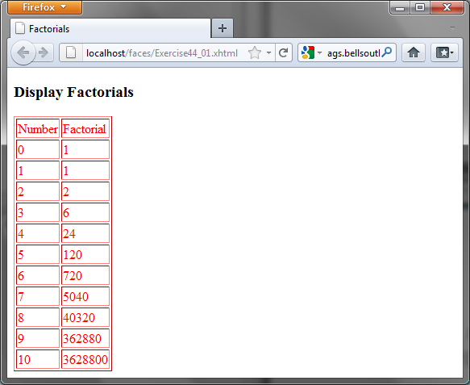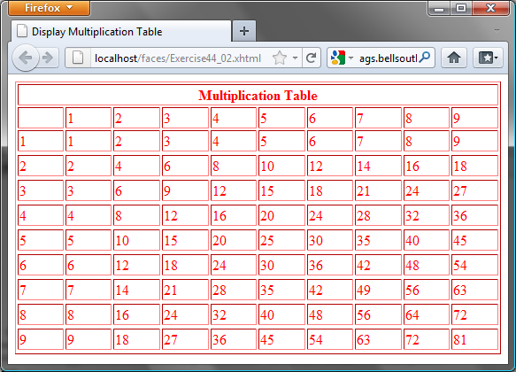

(a) (b)

Figure 44.24
(a) The JSF page displays factorials for the numbers from 0 to 10 in a table. (b) The JSF page displays the multiplication table.
44.2*
(Multiplication table) Write a JSF page that displays a multiplication table as shown in Figure 44.24b.

44.3*
(Calculate tax) Write a JSF page to let the user to enter taxable income and filing status, as shown in Figure 44.25a. Clicking the Compute Tax button invokes a servlet to compute and display the tax, as shown in Figure 44.25b. Use the computeTax method introduced in Listing 3.7, ComputeTax.java, to compute tax.

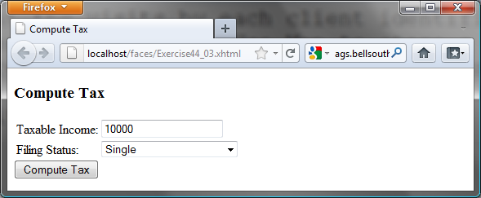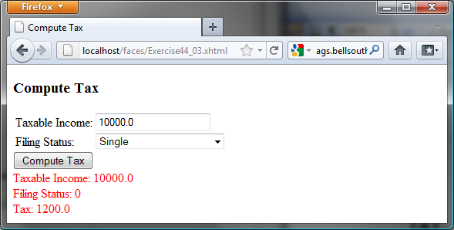

(a) (b)

Figure 44.25
The JSF page computes the tax.
44.4*
(Calculate loan) Write a JSF page that lets the user enter loan amount, interest rate, and number of years, as shown in Figure 44.26a. Clicking the Compute Loan Payment button to compute and display the monthly and total loan payments, as shown in Figure 44.26b. Use the Loan class given in Listing 10.2, Loan.java, to compute the monthly and total payments.

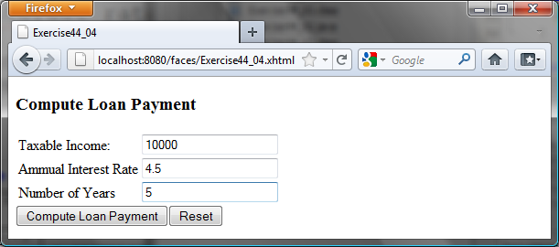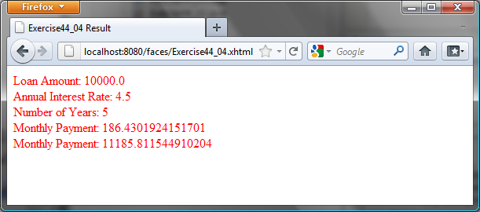

(a) (b)

Figure 44.26
The JSF page computes the loan payment.
44.5*
(Addition quiz) Write a JSF program that generates addition quizzes randomly, as shown in Figure 44.27a. After the user answers all questions, the JSP displays the result, as shown in Figure 44.27b.

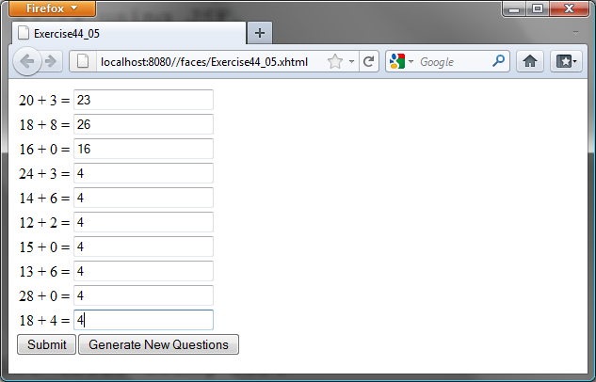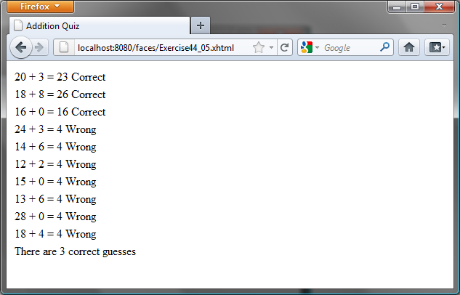

(a) (b)
Figure 44.27
The program displays addition questions in (a) and answers in (b).
43.18*
(Large factorial) Rewrite Exercise 44.1 to handle large factorial. Use the BigInteger class introduced in §15.11.

44.7*
(Guess birthday) Listing 3.3, GuessBirthDay.java, gives a program for guessing a birthday. Write a JSP program that displays five sets of numbers, as shown in Figure 44.28a. After the user checks the appropriate boxes and clicks the Find Date button, the program displays the date, as shown in Figure 44.28b.
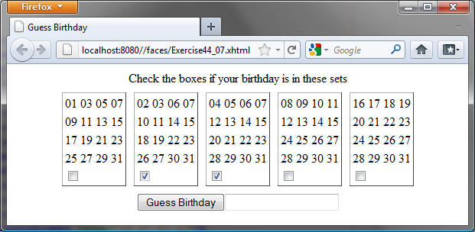
(a) (b)
Figure 44.28
(a) The program displays five sets of numbers for the user to check the boxes. (b) The program displays the date.
44.8*
(Guess capitals) Write a JSF that prompts the user to enter a capital for a state, as shown in Figure 44.29a. Upon receiving the user input, the program reports whether the answer is correct, as shown in Figure 44.29b. You can click the Next button to display another question. You can use a two-dimensional array to store the states and capitals, as proposed in Exercise 9.22. Create a list from the array and apply the shuffle method to reorder the list so the questions will appear in random order.

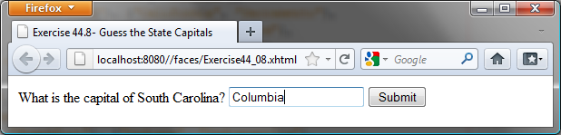
(a)

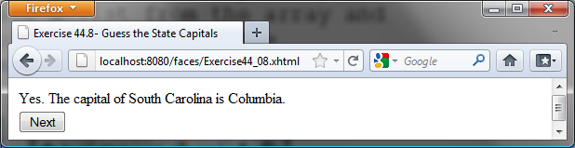
(b)

Figure 44.29
(a) The program displays a question. (b) The program displays the answer to the question.

44.9*
(Access and update a Staff table) Write a JSF program that views, inserts, and updates staff information stored in a database, as shown in Figure 44.30a. The view button displays a record with a specified ID. The Staff table is created as follows:
create table Staff (
id char(9) not null,
lastName varchar(15),
firstName varchar(15),
mi char(1),
address varchar(20),
city varchar(20),
state char(2),
telephone char(10),
email varchar(40),
primary key (id)
);

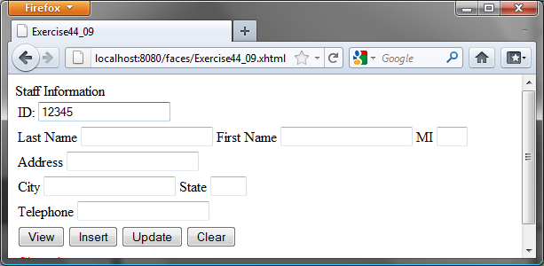

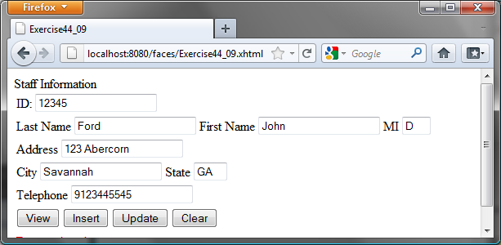

Figure 44.30
The web page lets you view, insert, and update staff information.
44.10*
(Random cards) Write a JSF that displays four random cards from a deck of 52 cards, as shown in Figure 44.22. When the user clicks the Refresh button, four new random cards are displayed.
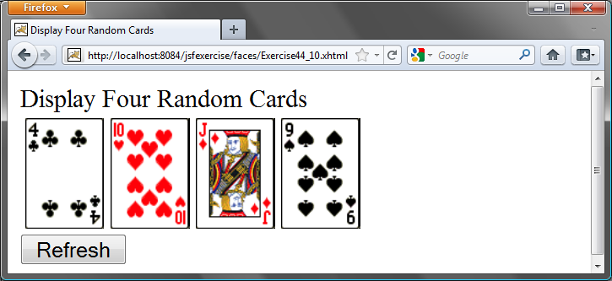
Figure 44.22
This JSF application displays four random cards.

44.11***
(Game: the 24-point card game) Rewrite Exercise 25.11 using JSF, as shown in Figure 44.23. Upon clicking the Refresh button, the program displays four random cards and displays an expression if a 24-point solution exists. Otherwise, it displays No solution.
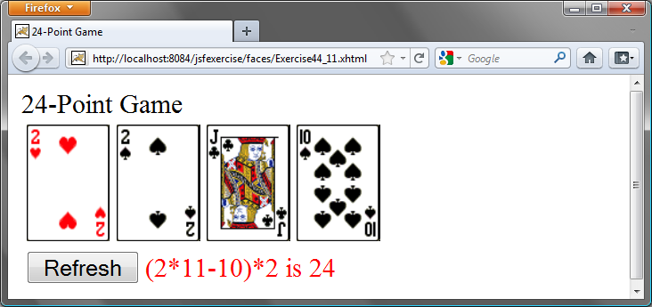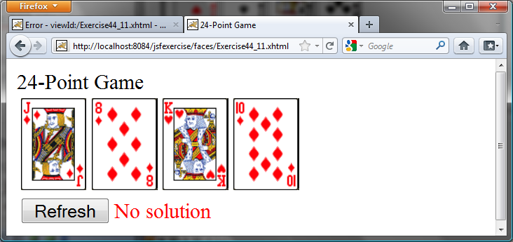
Figure 44.23
The JSF application solves a 24-Point card game.

44.12***
(Game: the 24-point card game) Rewrite Exercise 25.10 using JSF, as shown in Figure 44.24. The program lets the user enter four card values and finds a solution upon clicking the Find a Solution button.
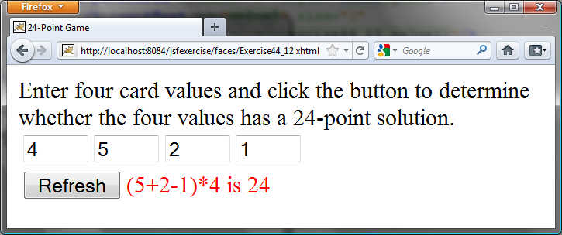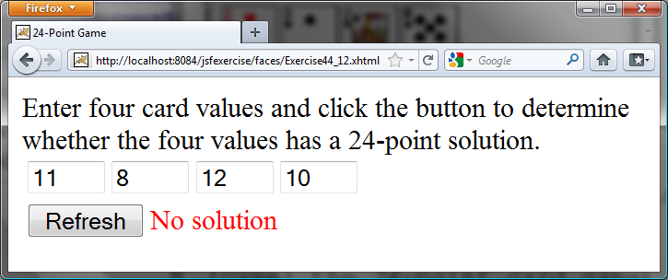
Figure 44.24
The user enters four numbers and the program finds a solution.

